Kubernetes Task-7
Task 1: Execute all yaml files shown in video.
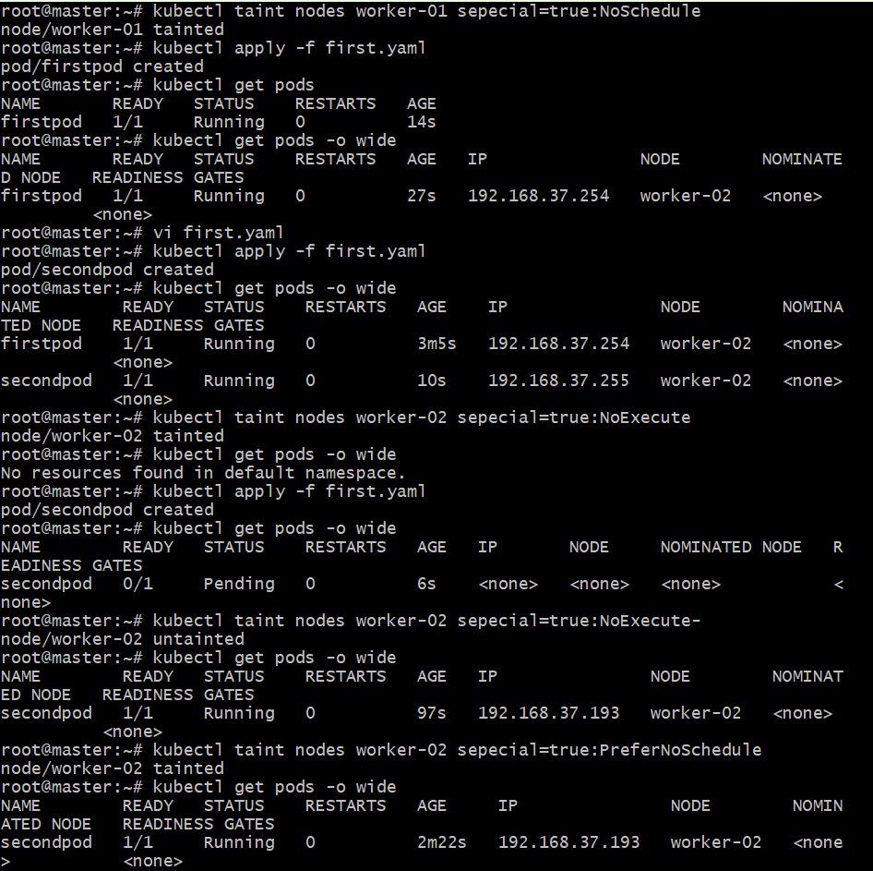
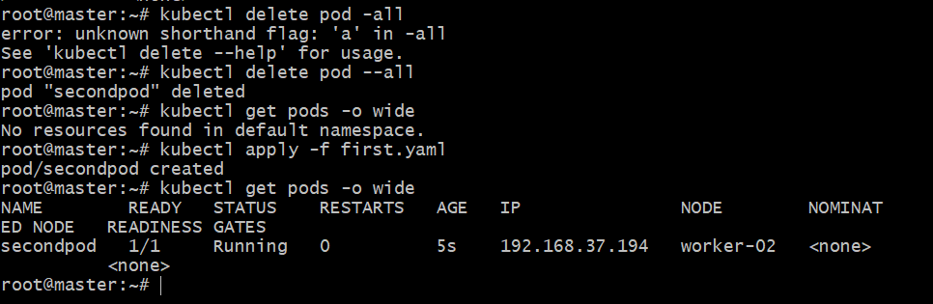
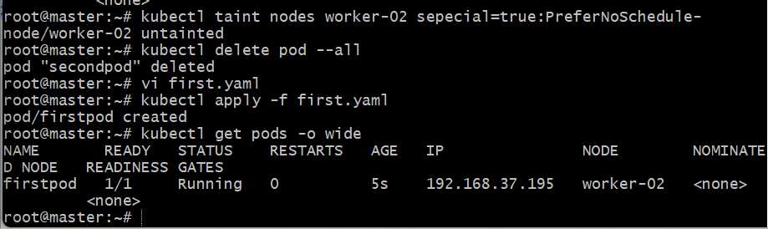
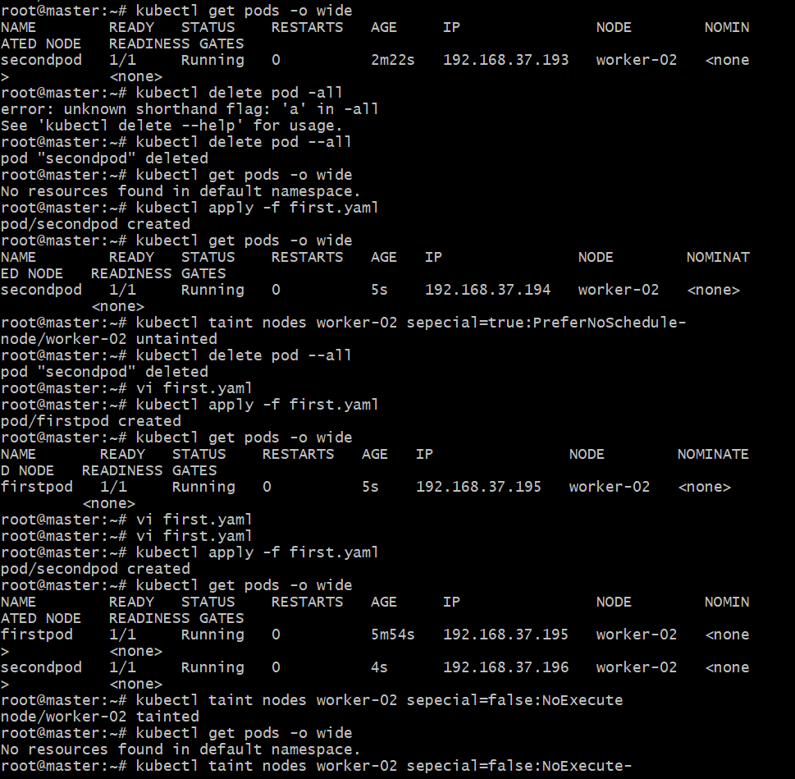
Task 2: Taint a Node and Schedule a Tolerant Pod Taint a node with special=true:NoSchedule. Create a pod with a toleration that matches the taint, allowing it to be scheduled on the tainted node.

Step 1: Taint the Node
Kubectl get pods
kubectl taint nodes ip-172-31-38-23 Special=true:NoSchedule
kubectl describe node ip-172-31-38-23 | grep Taints
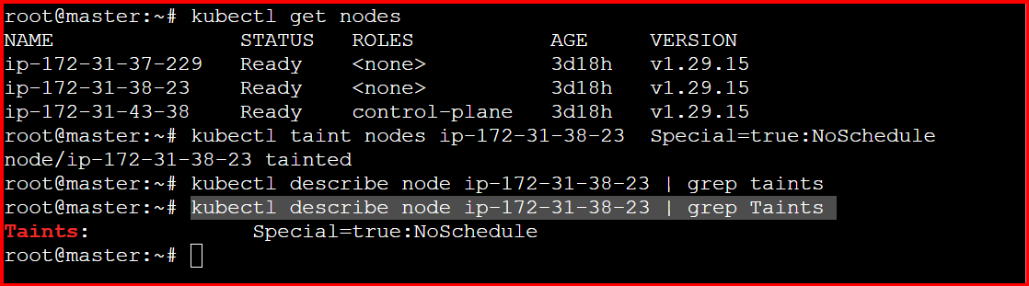
Step 2: Create a Pod with Toleration
vi tolerant-pod.yaml
apiVersion: v1
kind: Pod
metadata:
name: tolerant-pod
spec:
containers:
- name: nginx
image: nginx
tolerations:
- key: "special"
operator: "Equal"
value: "true"
effect: "NoSchedule"
kubectl apply -f tolerant-pod.yaml
kubectl get pods -o wide
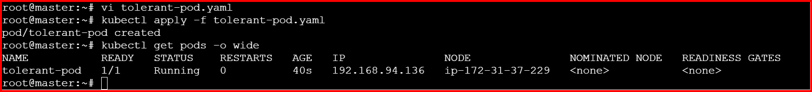

Task 3: Use NodeSelector to Schedule a Pod on a Specific Node Label a node with env=dev. Create a pod with a nodeSelector that schedules it only on the node labeled env=dev.

Step1:
Check the availability nodes (kubectl get nodes)
Step2:
Label a node (kubectl label node ip-172-31-38-23 env=dev)
Step3:
Verify the labels (kubectl get nodes --show-labels)
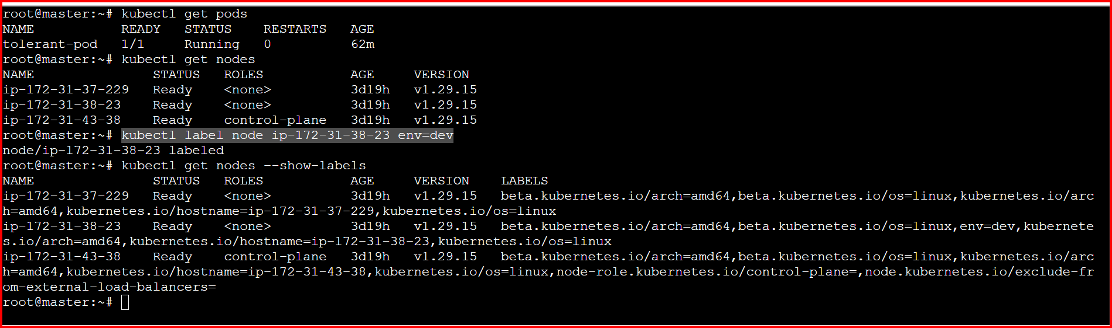
Step4:
Create a Pod with nodeSelector
Create a YAML file named node-selector-pod.yaml:
vi node-selector-pod.yaml

apiVersion: v1
kind: Pod
metadata:
name: dev-pod
spec:
containers:
- name: nginx
image: nginx
nodeSelector:
env: dev
kubectl apply -f node-selector-pod.yaml

kubectl get pod -o wide
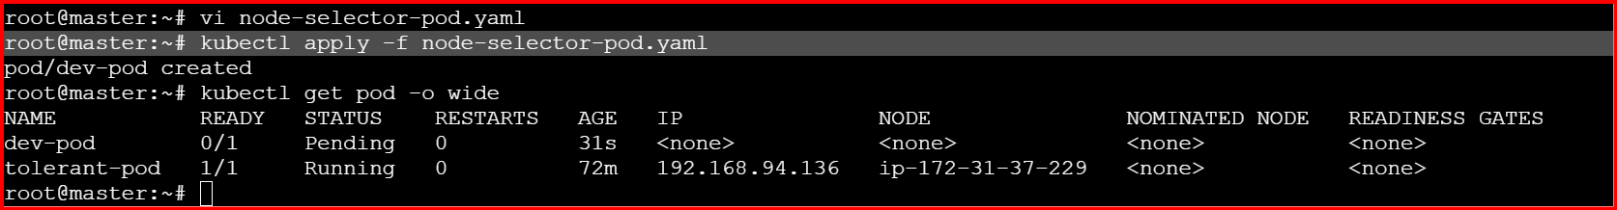

Task 4: Use Node Affinity with Soft Scheduling Label a
node with env=test. Create a pod with
Preferred During Scheduling Ignored During Execution
node affinity, preferring to schedule it on a node labelled
env=test. Remove the label and verify the pod continues
to run.

Step 1: Label the Node
kubectl label node ip-172-31-43-38 env=test
kubectl get nodes --show-labels
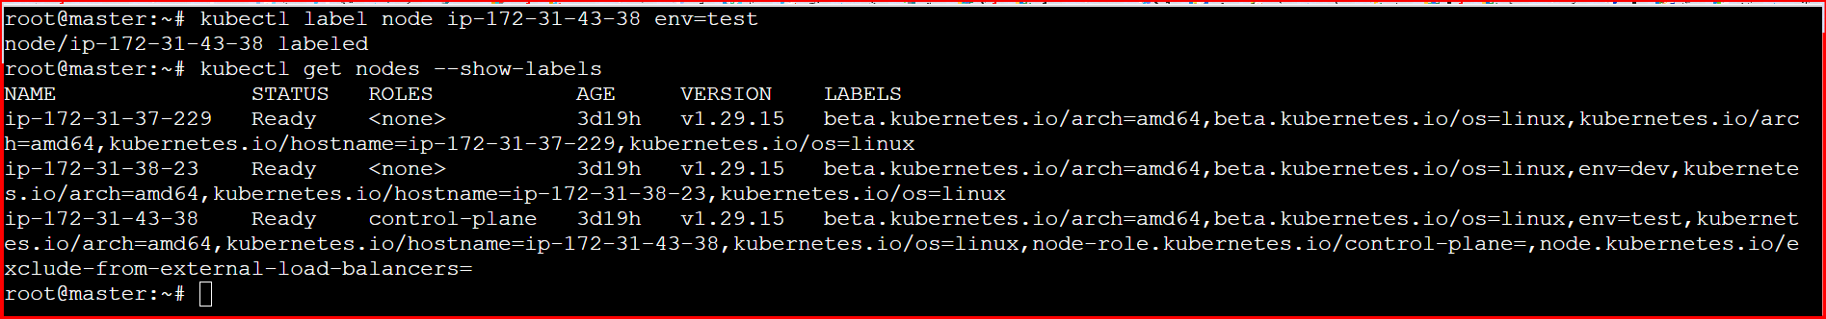

Create a Pod with Soft Node Affinity
vi affinity-pod.yaml
apiVersion: v1
kind: Pod
metadata:
name: affinity-pod
spec:
affinity:
nodeAffinity:
preferredDuringSchedulingIgnoredDuringExecution:
- weight: 1
preference:
matchExpressions:
- key: env
operator: In
values:
- test
containers:
- name: nginx
image: nginx

kubectl apply -f affinity-pod.yaml
kubectl get pod -o wide

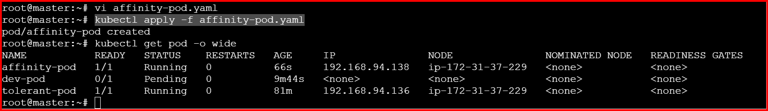
Remove the label:
kubectl label node worker-02 env-
kubectl get nodes --show-labels
kubectl get pod -o wide
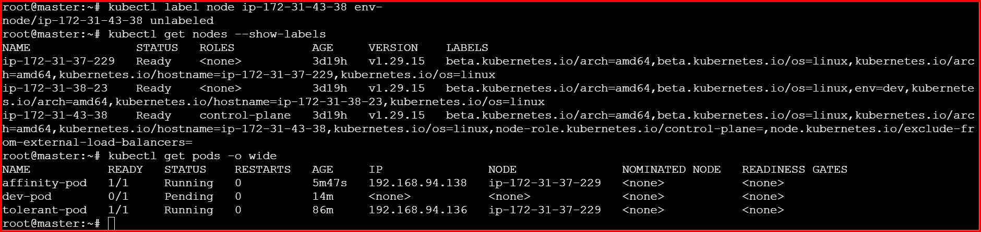

Task 5: Implement Node Affinity with Hard Scheduling Create a pod with RequiredDuringSchedulingIgnoredDuringExecution node affinity, ensuring it will only be scheduled on a node labeled env=prod. Verify the pod cannot be scheduled if no node has the env=prod label.
1. Create a pod that uses hard node affinity
(requiredDuringSchedulingIgnoredDuringExecution).
2. Ensure it schedules only on a node labeled env=prod.
3. Verify it stays Pending when no such label exists.
4. Add the label → confirm it schedules Step 1: Create the Pod YAML
Vi hard-affinity-pod.yaml
apiVersion: v1
kind: Pod
metadata:
name: hard-affinity-pod
spec:
affinity:
nodeAffinity:
requiredDuringSchedulingIgnoredDuringExecution:
nodeSelectorTerms:
- matchExpressions:
- key: env
operator: In
values:
- prod
containers:
- name: nginx
image: nginx
kubectl apply -f hard-affinity-pod.yaml
kubectl get pod -o wide
kubectl describe pod hard-affinity-pod
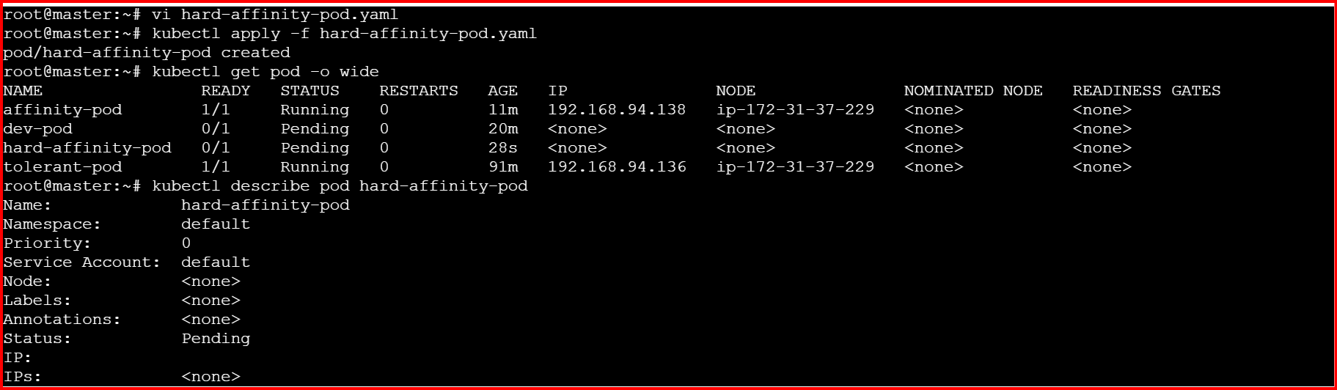
Add the Required Label
kubectl label node ip-172-31-43-38 env=prod
kubectl get nodes --show-labels
kubectl get pod -o wide
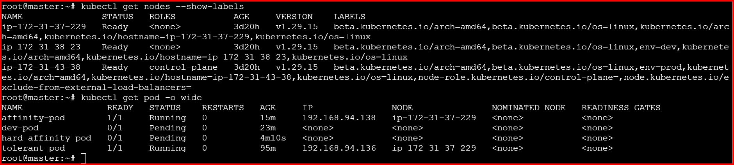
remove the label
kubectl label node ip-172-31-43-38 env-
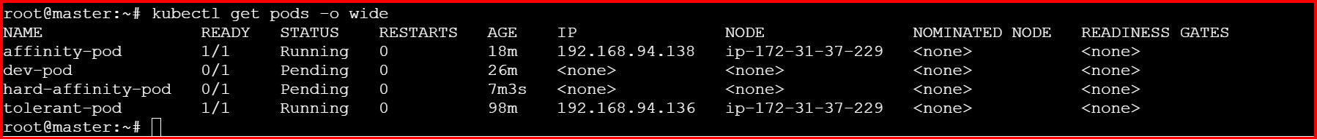

Task 6: Taint a Node and Use NoExecute with Toleration Seconds Taint a node with special=true:NoExecute. Create a pod with a tolerationSeconds field (e.g., 60 seconds) and observe it gets evicted after 60 seconds on the tainted node.

Step 1: Taint a Node
Choose a worker node (say worker-01) and taint it:
kubectl taint nodes ip-172-31-43-38 special=true:NoExecute Verify the taint:
kubectl describe node ip-172-31-43-38 | grep Taints
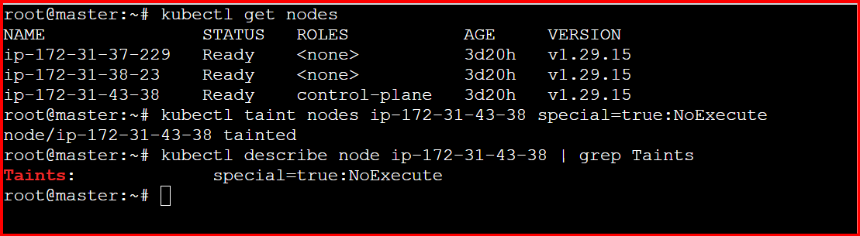
Step 2: Create a Pod with tolerationSeconds
Create a file named noexecute-pod.yaml:
apiVersion: v1
kind: Pod
metadata:
name: noexecute-pod
spec:
containers:
- name: nginx
image: nginx
tolerations:
- key: "special"
operator: "Equal"
value: "true"
effect: "NoExecute"
tolerationSeconds: 60
kubectl apply -f noexecute-pod.yaml
Then check where it is scheduled:
kubectl get pod -o wide

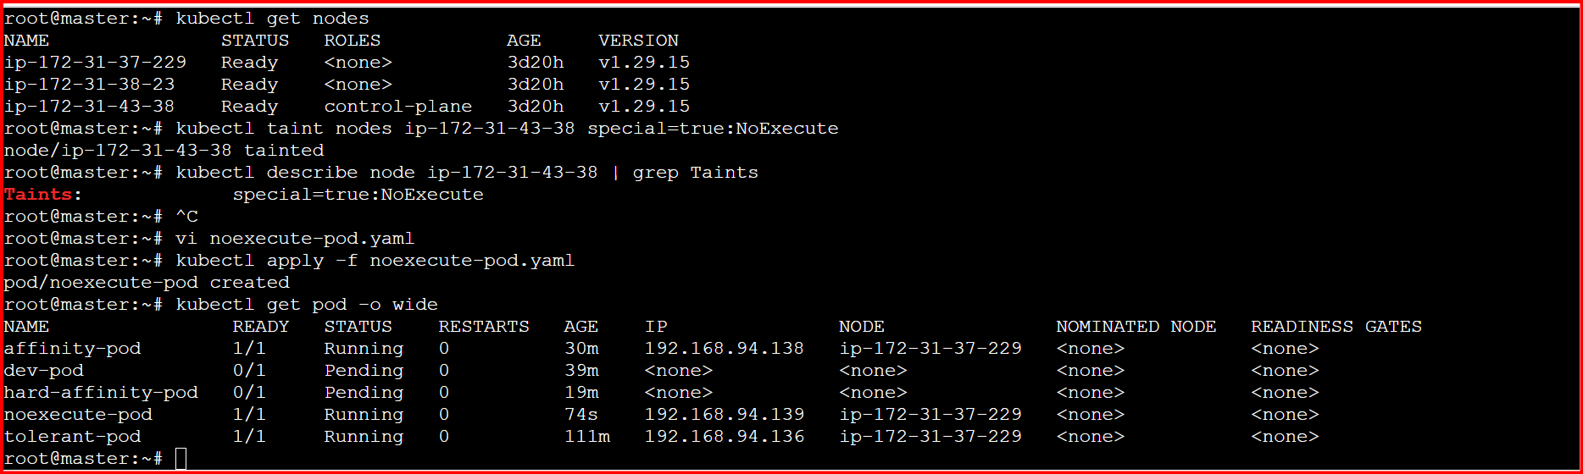

Remove the Taint
kubectl taint nodes ip-172-31-43-38 special=true:NoExecute-
